Table of Contents
- Program Overview
- Leadership Foundations for Management Accountants Course
- Registration Process
- Leadership Competency Development Plan
- Leadership Badge Community (IMA Leadership Forum)
- Leadership Courses
- Program Completion
- Post-Program Engagement
I. Program Overview

The Leadership Badge is a foundational leadership program that provides structured learning for professionals who want to move into leadership roles. The self-directed program is designed around the Leadership component of the IMA® (Institute of Management Accountants) Management Accounting Competency Framework (see diagram below). The goal of the program is to help members be more confident in taking on greater leadership challenges.
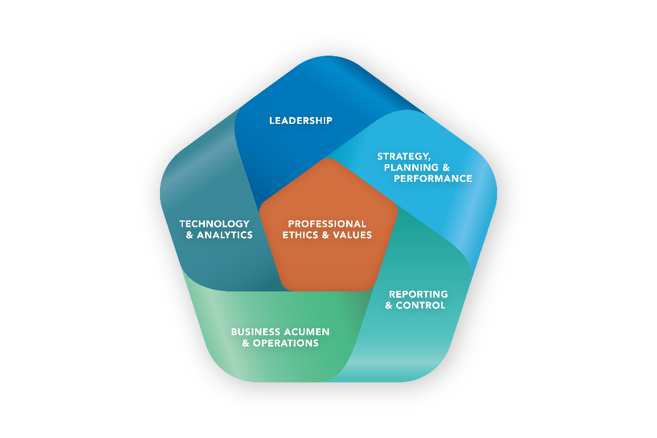

The competencies required to collaborate with others and inspire teams to achieve organizational goals:
- Communication Skills
- Motivating and Inspiring Others
- Collaboration, Teamwork, and Relationship Management
- Change Management
- Conflict Management
- Negotiation
- Talent Management

The Emerging Leader Badge program includes specific online courses, a leadership forum to learn from your peers, and a personal development plan to help improve in self-identified leadership areas. The program is designed to be completed within 12 months or less. The diagram below shows the components of the program and how they fit together.

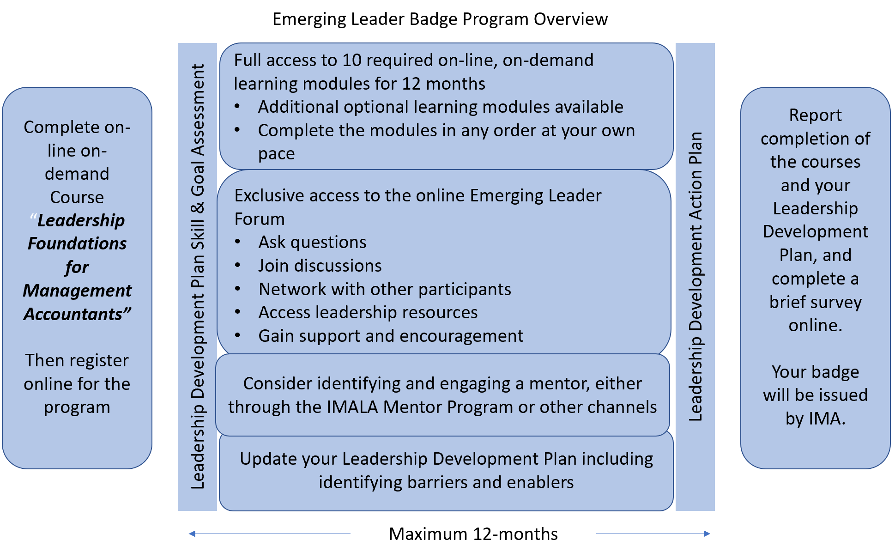

The following steps provide an overview of the progression of the program. Further explanations of key components are provided in the latter sections of this workbook.

- Complete the online self-study course Leadership Foundations for Management Accountants, which introduces the leadership competencies identified in the IMA Management Accounting Competency Framework.
- Register for the Emerging Leaders Badge program on the IMA website.
- Review the Leadership Competency Development Plan, and survey current skills and assess potential areas of improvement.
- Join and participate in the Emerging Leaders Badge Community (“Emerging Leaders”) on myIMA Network.
- Complete a series of online self-study leadership courses covering each leadership competency in more depth. Courses must be completed within one year of your acceptance to the program. Each course includes a knowledge assessment that must be passed with a score of 70% or higher for credit and CPE.
- Review your Leadership Competency Development Plan and determine specific actions to take to improve in self-identified areas.

The following additional steps are optional but recommended to maximize the effectiveness of your experience:

- Select a mentor as a sounding board for your Leadership Competency Development Plan. Your mentor may be someone at your current employer, a prior colleague, or a professional you know through IMA or another professional association. IMA offers an online mentoring program available through the IMA Leadership Academy (IMALA) on its website.
- Mentor others either through IMA or in other programs to practice leadership skills.

II. Leadership Foundations for Management Accountants Course

The Leadership Foundations for Management Accountants course identifies and explains the competencies of leadership upon which the Emerging Leaders Badge program is based. It provides insights into the competencies and suggests skills to develop to improve in these competency areas. These skills are then further explored in the coursework described later, which is aligned to each competency. This course is a critical overview to get the candidate into the mindset of a leader, and then each specific competency course deepens the knowledge necessary to develop as a leader. This course helps the candidate identify potential areas for the development plan.

III. Registration Process

The Emerging Leader Badge program is a self-directed program. It is a free member benefit under IMALA.

IV. Leadership Competency Development Plan

Throughout the course of the program, complete the Leadership Competency Development Plan according to the timing noted in the template. Refer to the template at each of the milestones below and work on developing your plan.

- After completion of Leadership Foundations for Management Accountants.
- At the end of each competency learning module.
- After completion of all course learnings.

One of the key outcomes of this plan is specific actions that you should take to improve your leadership competencies. The actions don’t have to be completed before the program is completed because some actions may be long-term in nature and improvement is an ongoing effort that extends beyond the scope of this program; however, the action plan should:

- Focus on the competencies that require the most improvement.
- Be tailored to the candidate’s career development and improvement.
- Use available resources from IMA or in the candidate’s work/volunteer environment.

The Leadership Competency Development Plan template is located in the Appendix.

V. Emerging Leaders Badge Community (IMA Emerging Leaders Forum)

One of the valuable components of the Emerging Leaders Badge program is access to an exclusive community of program participants, along with selected IMALA faculty and experienced leaders as moderators, on the myIMA Network. When you’re registered for the program, you’ll be granted access to the community. After completion of the program, alumni are encouraged to remain engaged in the community to help new members and foster a rich learning environment.

Participants are highly encouraged to post questions, post relevant materials or observations, or participate in discussion topics on the forum on a regular basis. Periodically, moderators will post questions or discussion topics based on the self-study course materials.

All posts must comply with IMA’s social media policy and be relevant to the topic of leadership in the context of management accounting. Violations of IMA’s social media policy may be grounds for termination of program access.

Here are some guidelines for participating in the community during the program:

- Visit the community at least once per week.
- Post questions about leadership or respond to other posts.
- Engage with facilitators or program alumni.
- Look for opportunities to add to the discussion (e.g., articles or book recommendations).
- Keep the discussion going through active dialogue.

VI. Leadership Courses

The courses listed below are available on demand and are required to be successfully completed to receive the Emerging Leaders Badge. If any of these courses have already been completed in prior sessions within the past year (live webinar or on demand), candidates don’t have to retake the course. Candidates will receive CPE credit for all courses taken as part of this program.

The initial course required for all candidates is Leadership Foundations for Management Accountants. Once this course is complete, the following courses should be completed as aligned with the leadership competencies (please note that additional resources listed are optional and not required to complete the program):

 | Leadership Competency | Courses
1 | Communication Skills - Listen effectively to others and convey thoughts or ideas through various forms of communication including written, spoken, and nonverbal. | Required:  - Communicating in the 21st Century  - Listening Skills  Additional Resources:  - Diversity & Inclusion
2 | Motivating and Inspiring Others - Influence, motivate, and gain support of others to achieve organizational goals using emotional intelligence, accountability, and setting the “tone at the top.” | Required:  - Workplace Motivation  - Emotional Intelligence  Additional Resources:  - Coaching
3 | Collaboration, Teamwork, and Relationship Management - Work effectively with others to achieve a trusting relationship that yields positive results. | Required:  - Teaming to Achieve  Additional Resources:  - Facilitation Skills  - Diversity & Inclusion
4 | Change Management - Lead an organization, team, or individuals through transition toward a desired vision or goal. | Required:  - Embracing Change  - Leading Change
5 | Conflict Management - Resolve issues using appropriate influencing skills and tools to achieve successful business goals and arrive at the best organizational outcomes. | Required:  - Successfully Managing Workplace Conflict
6 | Negotiation - Reach agreement between two or more parties to achieve the best outcome for the organization and an acceptable solution to negotiating parties. | Required:  - Negotiation
7 | Talent Management - Select, develop, retain, and reward people to ensure a strong workforce and successful business performance. | Required:  - Enhancing the Employee Experience  Additional Resources:  - Talent Management  - Diversity & Inclusion

VII. Program Completion

Once the coursework has been completed and the action plan has been developed, the candidate can sign onto the IMA website and complete the attestation stating that they have completed all of the necessary steps for the Emerging Leaders Badge. This webpage also includes a brief post-training survey to collect participant feedback and suggestions for improvement.

The attestation confirms that the candidate has taken all of the required courses, participated actively in the community, and developed a Leadership Competency Development Plan. Submittal of the online attestation indicates compliance with the IMA Statement of Ethical Professional Practice in the completion of program requirements. Following submission, the Emerging Leaders Badge will be granted and added to the member’s IMA profile. A digital badge will be available to display on social media to announce completion of the program.

IX. Post-Program Engagement

After candidates complete the program, they’re encouraged to remain engaged in the Emerging Leaders Badge Community through the discussion forum by helping other candidates as they work through the program and their action plans. Leadership is a constantly evolving skill that requires consistent practice and development. You may consider continuing your leadership development journey as a volunteer with IMA. See Volunteering with IMA to learn more about IMA volunteer opportunities and utilize the Volunteer Service Leader Framework to assist with finding the best opportunity for your leadership skill building.
APPENDIX
Leadership Competency Development Plan

You should prepare a professional development plan to help prioritize and develop skills that support the seven competencies in the Leadership domain of the IMA Management Accounting Competency Framework. A suggested format for the development plan is attached on page 2.

Complete the Plan Specifics on Page 2 to plan your professional development in pursuit of the leadership competencies. For each competency, you should identify one skill that you most need to develop. Why one? Because you can’t do everything all at once. Recommended interaction between the course modules and professional development plan:

Timing | Plans Specifics to Complete | Other Suggestions
During or after completing Leadership Foundations for Management Accountants module | (1) Skill and (2) Goal – For each competency, identify the skill you most need to develop based on module learnings and the results of your self-assessment and your goal for development of each skill. | You might consider also identifying (6) Priority at this point if you would prefer to prioritize your progression through the competency learning modules.
During or after completing each competency learning module(s) (e.g., Negotiation module) | (3) Barriers, (4) Enablers, and (5) Actions – As you complete the learning module(s) for each competency, list the barriers (things that might prevent you) and enablers (things that support you) in developing each skill in (1). Identify specific actions you’ll take to develop each skill. | This is a great area to consult with your leadership mentor for guidance.
After completing all course learnings | (6) Priority and (7) Due Date – Remember that you can’t do everything all at once; you prioritized specific skills, but you also need to prioritize the order you will tackle the skills. Rank each skill competency from 1 to 7, with 1 being the skill you want to work on developing first. Hold yourself accountable by establishing due dates. | If you previously identified (6) Priority, review this and make any desired changes.

With whom will you share this development plan to help hold you accountable to complete it?

_______________________________________________________________

PLAN SPECIFICS
 | 1 | 2 | 3 | 4 | 5 | 6 | 7
 | Skill | Goal | Barriers | Enablers | Actions | Priority | Due Date
Competency | What competency skill do you most need to develop? | What is your goal for developing this skill? | What are the barriers in developing this skill? | What are the enablers in developing this skill? | What specific action steps will you take to overcome the barriers and nurture the enablers to develop this skill? | From 1 to 7, how does this skill rank in priority? | What is your due date in developing this skill?
Communication Skills
Motivating and Inspiring Others
Collaboration, Teamwork, and Relationship Management
Change Management
Conflict Management
Negotiation
Talent Management

